**SPRINT 1 REPORT**

**Team Name**: Camphyr

**Team Members**: Nicole Kyriakopoulos, Kirby Lam, Alex Mayben, Michelle Meng, Raymond Mai

**Date**: April 23th, 2018

Actions to start doing:

* Stay on focus/topic during meetings
* Be more prepared for meetings
* Start pair programming

Actions to stop doing:

* Stop messing up with Git

Stories completed: None so far

Stories not completed:

* 5 - As a user, I want to write and post story snippets to a platform where they will then be stored
* 5 – As a user, I want to add to other snippets with my own.
* 5 – As a user, I want to easily find other snippets, so I can add onto them.
* 3 – As a user, I want to name my stories so that I can keep track of them later.

Work Completion Rate:

* 1. Total number of user stories completed: 0
* 2. Total number of estimated work hours completed collectively as a team: 34
* 3. Total number of days during the sprint: 14
* 4. User stories completed per day: 0
* 5. Hours worked per day: 3

**Burnup Chart:**

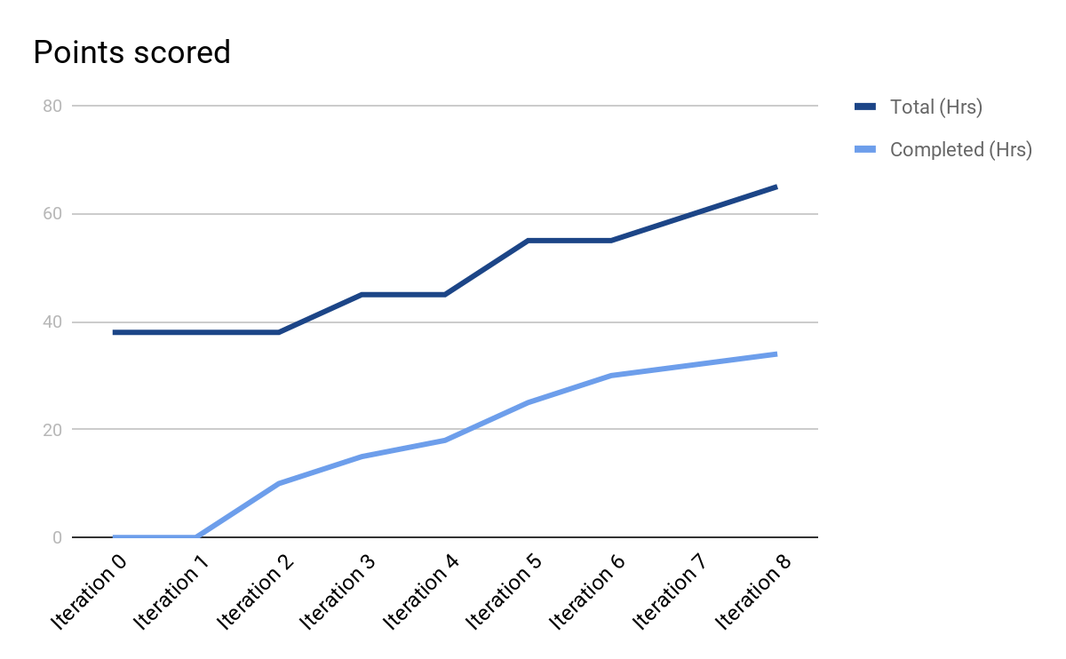

**SCRUM BOARD**

|  |  |  |  |  |
| --- | --- | --- | --- | --- |
| User Story | To Do | In Progress | Done | No longer needed |
| As a user, I want to write and post story snippets to a platform where they will then be stored. |  | Task 3: Save that result to the database where it can be accessed later, not just from a page refresh.  Time estimate: 6 hours | Task 1: Research database options and find a suitable platform.  Time estimate: 7 hours  Task 2: Code a responsive textbox using Javascript that returns the result to a unique webpage.  Time estimate: 2 hours  Task 4.a: Limit the submission to 200 characters.  Time estimate: 1 hour  Task 4.b: Once the character limit has been achieved, then increase the limit to 2500 characters.  Time estimate: 0 hours |  |
| “As a user, I want to add to other snippets with my own.” | Task 4: Limit the number of snippets per story to 10.  Time estimate: 1 hour  Task 5: Add a blurb for when the 10th snippet is being written.  Time estimate: 0 hours |  | Task 1: Research linked lists in Javascript and how to use them.  Time estimate: 3 hours | Task 2: Define each snippet as a node object in a linked list.  Time estimate: 2 hours  Task 3: Establish the starting snippet as the head of a new linked list.  Time estimate: 2 hours  Task 6: Add a text box and submit button to the tail node of the linked list.  Time estimate: 1 hour  Task 7: Create and store multiple linked lists in this manner.  Time estimate: 2 hours |
| “As a user, I want to easily find other snippets, so I can add onto them.” | Task 1: Maintain a summary of 20 most recent snippets logged into the database.  Time estimate: 3 hours  Task 3: Make the snippets accessible from a specific page on the site.  Time estimate: 2 hours |  |  | Task 2: Identify the snippets by the first 20 characters of the head node in the linked list.  Time estimate: 2 hours |
| As a user, I want to name my stories so that I can keep track of them later | Task 1: Have an optional text box during the story creation for the title with a limit of 30 characters.  Time estimate: 2 hours  Task 2: Have the title be displayed on that story’s page.  Time estimate: 1 hour  Task 3: Make title visible on story listing for story search page.  Time estimate: 1 hour |  |  |  |